Knowledge & Study Center
Our Knowledge & Study Center is dedicated to empowering students with quality education and structured learning methods. We provide expert guidance, updated study materials, and a focused environment to help learners achieve their goals. Our approach combines concept clarity, regular practice, and performance tracking. We aim to build confidence and consistency in every student. Join us to experience smart learning and success-driven preparation.

Courses We Offer
1. TTP (Train The Program)
A skill-focused program designed to enhance aptitude, reasoning, and problem-solving abilities for competitive success.
2. TNPSC
Comprehensive coaching for Tamil Nadu Public Service Commission exams with updated syllabus and regular mock tests.
3. SSC
Structured preparation for Staff Selection Commission exams covering quantitative aptitude, reasoning, and general awareness.
4. RRB
Focused training for Railway Recruitment Board exams with exam-oriented strategies and practice sessions.
5. Banking
Complete coaching for bank exams including IBPS and SBI, with emphasis on speed, accuracy, and concept mastery.

Padaipagam 1
Padaipagam is a creative learning space designed to nurture young minds through skill-based and engaging programs. We focus on developing creativity, logical thinking, and real-world skills in students. Our expert mentors ensure a fun and interactive learning environment. Through practical sessions and guided activities, students gain confidence and knowledge. Padaipagam is the perfect place for students to learn, explore, and grow beyond academics.

TNPSC
Comprehensive coaching for Tamil Nadu Public Service Commission exams with updated syllabus and regular mock tests.

Summer Camp Programs
1. Chess
Enhance strategic thinking, concentration, and decision-making skills through expert-led chess training.

2. Tally with GST
Learn accounting fundamentals and GST concepts with hands-on training using Tally software.

3. AI & Digital Marketing
Get introduced to Artificial Intelligence and modern digital marketing tools and strategies.

4. Abacus
Improve mental math skills, memory, and concentration through structured abacus training.


Padaipagam 2
Padaipagam is a vibrant platform that inspires students to discover their talents through innovative and activity-based learning. We create an environment where curiosity meets creativity, helping students think independently and explore new ideas. Our programs are designed to make learning enjoyable while building essential life skills. With dedicated mentors and interactive sessions, students gain both knowledge and confidence. At Padaipagam, every learner is encouraged to grow, create, and succeed in their own unique way.

TNPSC
Comprehensive coaching for Tamil Nadu Public Service Commission exams with updated syllabus and regular mock tests.

Summer Camp Programs
1. Mandala
Explore creativity and mindfulness through mandala art, enhancing focus, patience, and artistic expression.
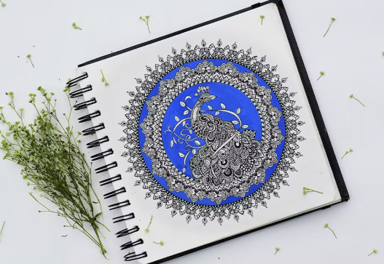
2. STEM
Hands-on learning in Science, Technology, Engineering, and Mathematics to build innovation and problem-solving skills.
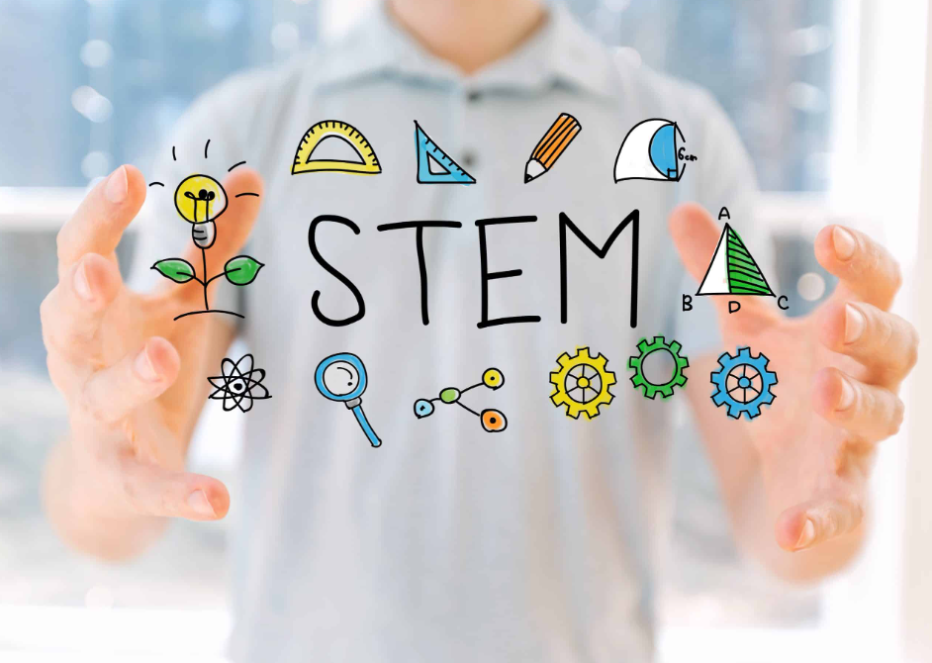
3. Junior Coders
An introductory coding program for kids to develop logical thinking and basic programming skills in a fun way.
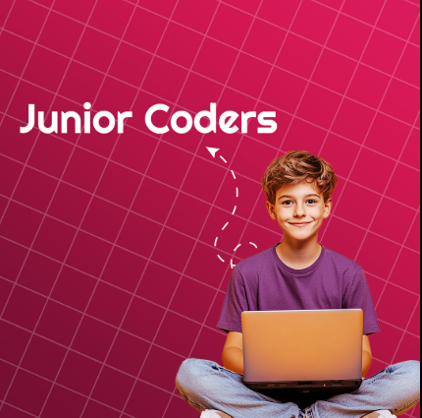
4. Acrylic and Sketch
Learn drawing and painting techniques to express creativity through acrylic colors and sketching.

Exam Logo :
TNPSC: 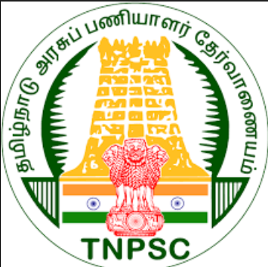

UPSC: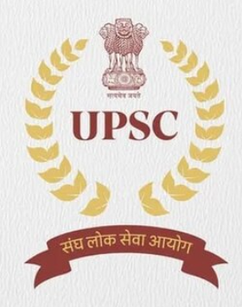

RRB:
SSC:
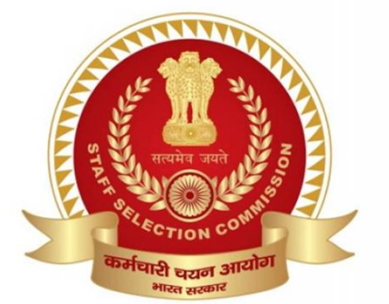

Banking:

